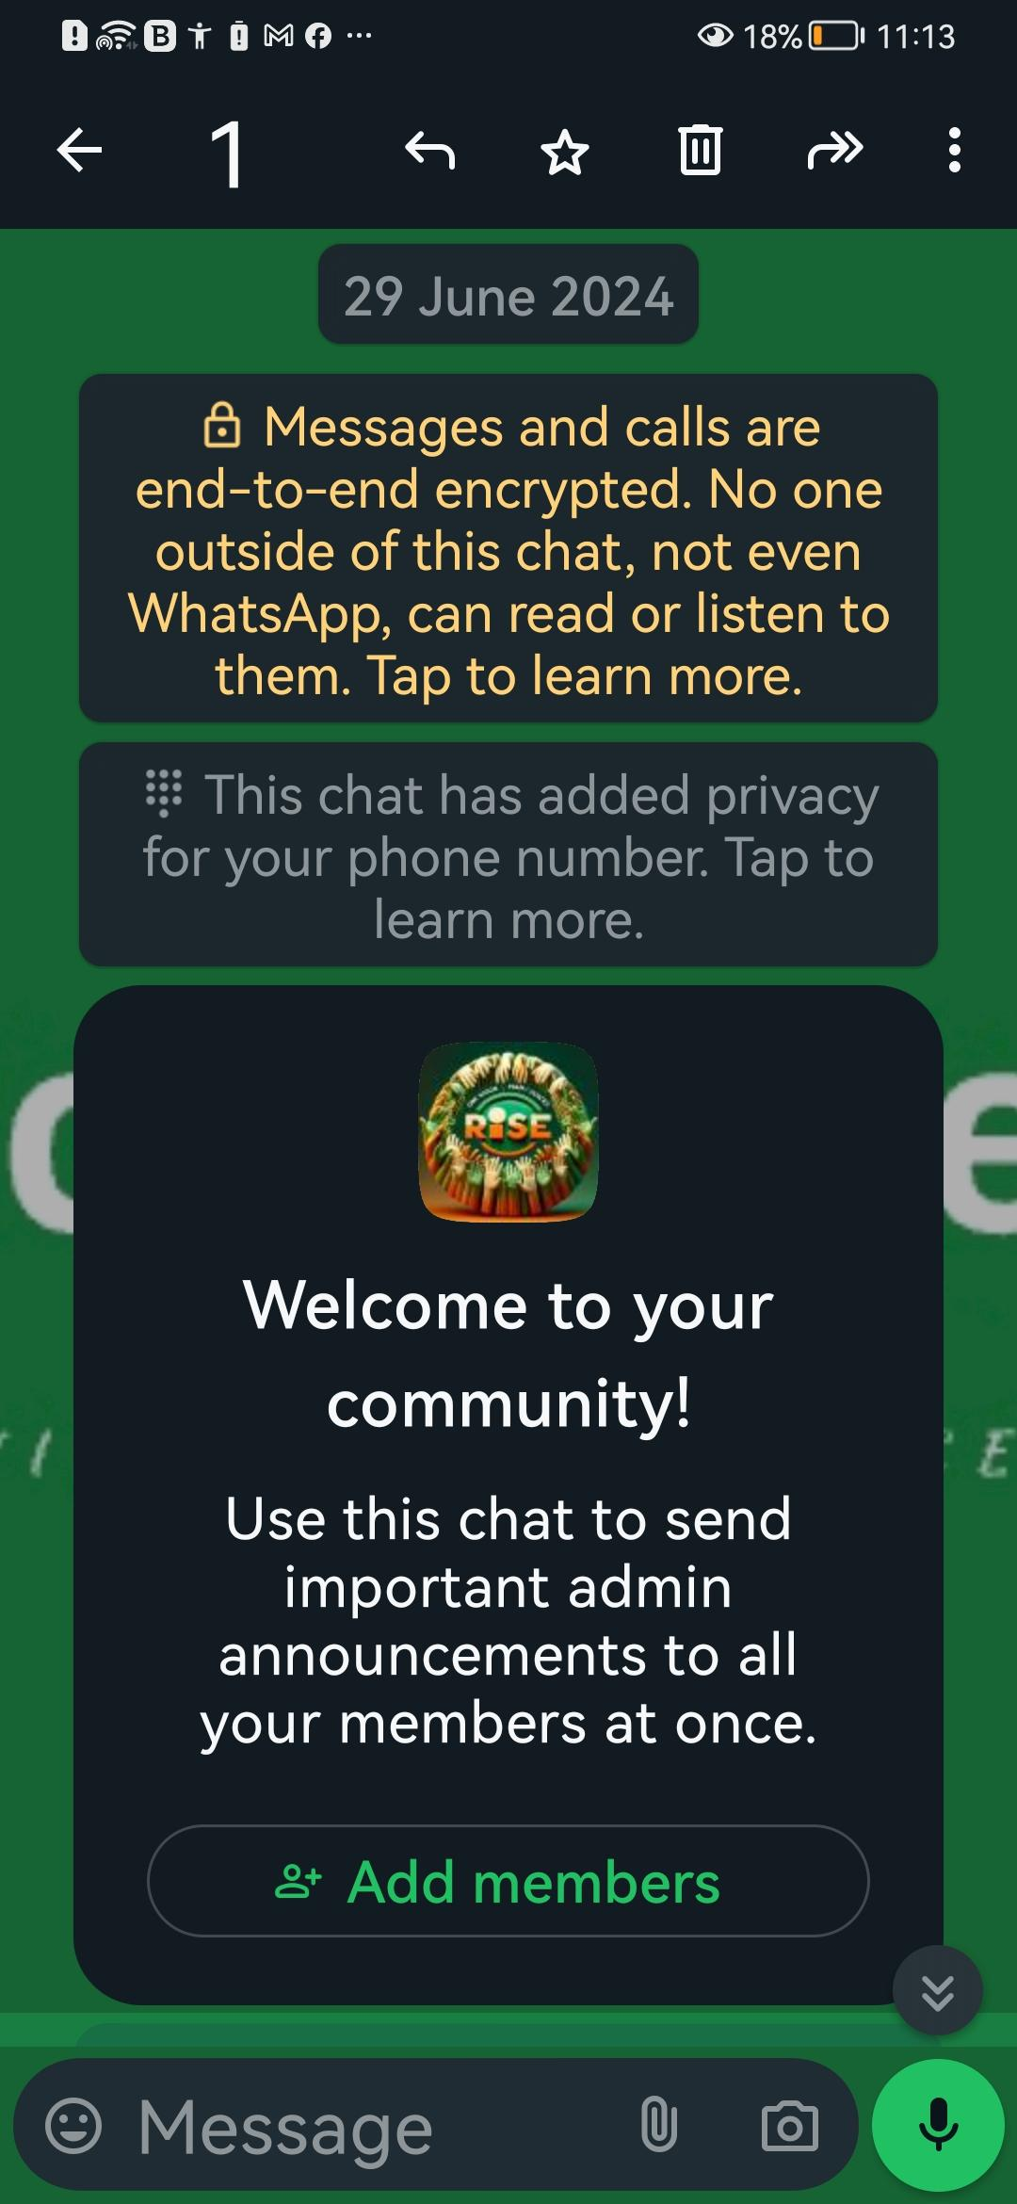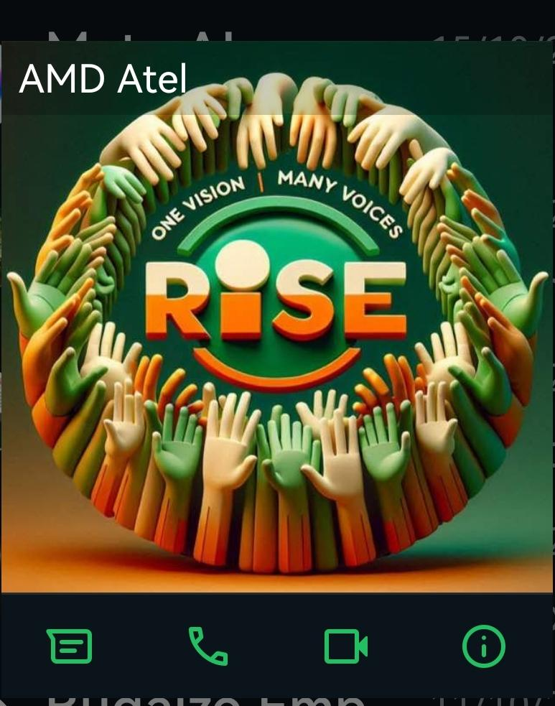RiseTogether NG
Tagline: Empowering Unity
Imagery: Hands reaching up, forming a circle, symbolizing unity and support.
Colors: A gradient from green (growth, harmony) to orange (energy, creativity).
Typography: A modern, clean, sans-serif font that’s easily readable and inclusive.
Style: Minimalistic yet powerful, conveying a clear message without clutter.
Based on this brief, I’ll create a conceptual sketch for the logo:

RiseTogether NG
----------------

- A circle of stylized hands reaching upwards, interlocking to show support and unity.
- The name "RiseTogether NG" prominently displayed at the top or bottom of the circle in bold, clear letters.
- A tagline "Empowering Unity" in a smaller font, capturing the essence of the community's mission.
- A color palette that transitions smoothly from a rich green to a vibrant orange, representing the community's growth and energy.
- A font that's modern and accessible, reflecting the community's forward-thinking and inclusive nature.

This concept aims to be versatile, ensuring the logo is effective across various mediums, from digital platforms to print materials. It’s designed to be scalable, maintaining its impact whether it’s on a small profile picture or a large banner.
[29/06, 19:18] Just Believe: I have to set up
mighty network
[29/06, 19:19] Just Believe: I have to create a logo
[29/06, 19:19] Just Believe: I have to create a domain and website design
[29/06, 19:35] Just Believe: Welcome Post for New Members

Welcome to RiseTogether NG – a place where your talents shine and your dreams take flight! 🚀

Here, we believe in the power of unity to transform lives. Whether you're an artist, a musician, a comedian, or just someone with a big dream, you've found a family that supports you.

Dive into our forums, share your journey, and let's grow together. Your story is our inspiration, and your success is our mission. Together, we rise!
[29/06, 19:38] Just Believe: Motivational Blog Post

**Empowerment Through Unity: The RiseTogether NG Way**

In the heart of every individual lies a unique talent waiting to be discovered. At RiseTogether NG, we see the potential in each of you – the potential to create, to entertain, and to inspire.

But what does it take to turn potential into reality? It takes a community. It takes a collective effort where every like, comment, and share is a step towards someone's dream. It's about lifting each other up, celebrating every victory, and facing every challenge together.

Join us on this incredible journey. Be part of a movement where every member is a pillar of support. Let's build a future where talent thrives and no dream is too big to achieve.

Because when we rise together, we can reach heights we never thought possible.
[29/06, 19:40] Just Believe: Inspirational Social Media Post

🌟 #MemberSpotlight 🌟

Meet Ada, a vibrant poet from Lagos whose words have the power to touch hearts. She joined RiseTogether NG with a notebook full of verses and a dream to share them with the world.

Today, Ada's poetry has reached thousands, bringing hope and joy to many. Her story is a testament to what we can achieve when we support each other.

Your talent deserves the spotlight. Share your creations with us, and let's make the world a brighter place, one masterpiece at a time. 💫

#RiseTogetherNG #Empowerment #CommunityLove
[29/06, 19:41] Just Believe: Email Newsletter Snippet

🌈 RiseTogether NG Monthly Highlights 🌈

Dear RiseTogether family,

What a month it's been! From John's viral comedy skit to Fatima's breathtaking dance performance, we've seen our members reach new heights and bring smiles to faces across Nigeria.

Here's a quick roundup of what's been happening:
- Our online workshop series kicked off with a bang, featuring experts in various creative fields.
- The "RiseTogether Challenges" have sparked incredible creativity, with members pushing the boundaries of their talents.

Don't forget to check out our upcoming events and get involved. Your participation is what fuels this community's fire!

Together, we're not just dreaming – we're achieving.

Warm regards,
The RiseTogether NG Team
[29/06, 19:45] Just Believe: Educational Resource Post

**Free Workshop Alert: Mastering Social Media for Creatives**

Want to learn how to showcase your talent on social media? Join our free workshop this Saturday, where we'll cover everything from creating engaging content to growing your follower base.

Secure your spot now and take the first step towards social media mastery!

#SocialMediaTips #CreativeWorkshop #RiseTogetherNG
[29/06, 19:45] Just Believe: Weekly Challenge Announcement

🎨 Weekly Creativity Challenge: #RiseWithArt 🎨

This week, we're challenging you to create something that represents what "RiseTogether NG" means to you. It could be a drawing, a poem, a song, or even a dance!

Post your creations with the hashtag #RiseWithArt and let's fill our community with expressions of unity and empowerment.

#WeeklyChallenge #CommunityArt #RiseTogetherNG
[29/06, 19:46] Just Believe: Member Achievement Feature

🌟 Celebrating Success: Chinedu's Fashion Line Launch 🌟

From sketching designs in his notebook to launching his own fashion line, Chinedu's journey has been nothing short of remarkable. His passion for blending traditional patterns with modern style has captured the hearts of many.

Join us in congratulating Chinedu on this incredible milestone. Your story is a beacon of hope for aspiring entrepreneurs in our community.

#MemberSuccess #FashionForward #RiseTogetherNG

Weekly Challenge Announcement

🎨 Weekly Creativity Challenge: #RiseWithArt 🎨

This week, we're challenging you to create something that represents what "RiseTogether NG" means to you. It could be a drawing, a poem, a song, or even a dance!

Post your creations with the hashtag #RiseWithArt and let's fill our community with expressions of unity and empowerment.

#WeeklyChallenge #CommunityArt #RiseTogetherNG

Educational Resource Post

**Free Workshop Alert: Mastering Social Media for Creatives**

Want to learn how to showcase your talent on social media? Join our free workshop this Saturday, where we'll cover everything from creating engaging content to growing your follower base.

Secure your spot now and take the first step towards social media mastery!

#SocialMediaTips #CreativeWorkshop #RiseTogetherNG
[29/06, 19:46] Just Believe: Weekly Challenge Announcement

🎨 Weekly Creativity Challenge: #RiseWithArt 🎨

This week, we're challenging you to create something that represents what "RiseTogether NG" means to you. It could be a drawing, a poem, a song, or even a dance!

Post your creations with the hashtag #RiseWithArt and let's fill our community with expressions of unity and empowerment.

#WeeklyChallenge #CommunityArt #RiseTogetherNG
[29/06, 19:46] Just Believe: Member Achievement Feature

🌟 Celebrating Success: Chinedu's Fashion Line Launch 🌟

From sketching designs in his notebook to launching his own fashion line, Chinedu's journey has been nothing short of remarkable. His passion for blending traditional patterns with modern style has captured the hearts of many.

Join us in congratulating Chinedu on this incredible milestone. Your story is a beacon of hope for aspiring entrepreneurs in our community.
[29/06, 19:47] Just Believe: Inspirational Quote Graphic

"Alone we can do so little; together we can do so much." – Helen Keller

Let this quote be a reminder that our strength lies in unity. When we support each other, there's no limit to what we can achieve. Share this if you believe in the power of community!

#Unity #StrengthInNumbers #RiseTogetherNG
[29/06, 19:48] Just Believe: Inspirational Quote Graphic

"Alone we can do so little; together we can do so much." – Helen Keller

Let this quote be a reminder that our strength lies in unity. When we support each other, there's no limit to what we can achieve. Share this if you believe in the power of community!

#Unity #StrengthInNumbers #RiseTogetherNG
[29/06, 19:48] Just Believe: Forum Discussion Starter

**What's Your Creative Process?**

Hey, RiseTogether fam!

We all have our unique ways of sparking creativity. Whether it's through music, a walk in nature, or a good old brainstorming session, we want to hear about what gets your creative juices flowing.

Share your creative process in the comments below and let's inspire each other with new ways to ignite that artistic fire!

#CreativeProcess #Inspiration #RiseTogetherNG
[29/06, 19:54] Just Believe: RiseTogether NG” will not only be a platform for showcasing talent but also a catalyst for growth and success.
[29/06, 21:55] Just Believe: *RiseTogetherNG PROFILE*

*Community Name: RiseTogether NG*

*Slogan: “One Vision, Many Voices, United in Rise”*

Mission: To empower every individual’s dream by fostering a supportive community where talents are nurtured, voices are heard, and collective success is achieved.

Vision: A world where every talent has the opportunity to flourish and every dream has the support to become a reality.

Values:

Empowerment: Providing tools and resources for personal and professional growth.
Unity: Bringing together diverse talents to create a stronger whole.
Inclusivity: Ensuring every member feels valued and included.
Inspiration: Sharing stories of success and resilience to motivate and encourage.
Collaboration: Encouraging partnerships and teamwork to reach common goals.
What We Do:

Host talent showcases and skill-sharing sessions.
Offer educational workshops and mentorship programs.
Celebrate cultural diversity and promote inclusivity.
Provide a platform for networking and collaboration.
Support members in achieving monetization and recognition.
Who We Are: A vibrant community of creatives, entrepreneurs, and dreamers united by the belief that together, we can rise above challenges and make a lasting impact.

Join Us: If you have a talent to share, a dream to chase, or a voice to be heard, “RiseTogether NG” is your community. Together, we can turn aspirations into achievements.
[29/06, 22:06] Just Believe: *SLOGAN*

*Empowering Every Dream, Together We Rise”:*

emphasizes individual empowerment as part of the collective journey. It suggests that the community is there to support each member’s personal aspirations, reinforcing the idea that individual success contributes to the group’s upliftment.

“ *One Vision, Many Voices, United in Rise”:*

highlights the diversity within the community and the strength that comes from uniting different voices towards a common goal. It speaks to the inclusivity of the community and the collaborative effort to achieve shared success.
[29/06, 22:14] Just Believe: *RiseTogetherNG PROFILE*

*Community Name: RiseTogether NG*

*Slogan: “One Vision, Many Voices, United in Rise”*

*MISSION* :
To empower every individual’s dream by fostering a supportive community where talents are nurtured, voices are heard, and collective success is achieved.

*VISION*
A world where every talent has the opportunity to flourish and every dream has the support to become a reality.

*VALUES* :
Empowerment: Providing tools and resources for personal and professional growth.

*UNITY* :
Bringing together diverse talents to create a stronger whole.

*INCLUSIVITY* : Ensuring every member feels valued and included.
Inspiration: Sharing stories of success and resilience to motivate and encourage.
Collaboration: Encouraging partnerships and teamwork to reach common goals.

**What We Do* :Host talent showcases and skill-sharing sessions.
Offer educational workshops and mentorship programs.
Celebrate cultural diversity and promote inclusivity.
Provide a platform for networking and collaboration.
Support members in achieving monetization and recognition.

*Who We Are* : A vibrant community of creatives, entrepreneurs, and dreamers united by the belief that together, we can rise above challenges and make a lasting impact.

*Join Us* : If you have a talent to share, a dream to chase, or a voice to be heard, “RiseTogether NG” is your community. Together, we can turn aspirations into achievements.

